Create a class called Person with properties such as name, age, gender, address. Include
getter and setter methods for each property.
Introduction: Writing a Java Person class with all of a person's personal information is our task. This information includes their name, residence, gender, and age. We will offer getter and setter methods for each property to ensure data integrity and encapsulation.

Lab Report:
Experiment:
1. Create a new Java class and give each member of the class a name.
2. Create instance-specific private variables: Make name, age, gender, and address private variables. The pertinent personal information will be stored in these variables.
3. Apply getters and setters methods: Make these hidden variables available to the public and able to be changed.
o Getter methods: These methods return the value of the related private variable. For example, the getName() function returns the person's name.
o Setter methods: These allow you to change the value of the private variable. For example, the setName(String name) function sets the person's name.

Code Implementation:
public class Person {
private String name;
private int age;
private String gender;
private String address;

public Person(String name, int age, String gender, String address) {
this.name = name;
this.age = age;
this.gender = gender;
this.address = address;
}

public String getName() {
return name;
}

public void setName(String name) {
this.name = name;
}

public int getAge() {
return age;
}

public void setAge(int age) {
if (age >= 0) { // Optional: validation to ensure age is not negative
this.age = age;
} else {
System.out.println("Age cannot be negative.");
}
}

public String getGender() {
return gender;
}

public void setGender(String gender) {
this.gender = gender;
}

public String getAddress() {
return address;
}

public void setAddress(String address) {
this.address = address;
}

// Optional: Override toString() method for easy printing
@Override
public String toString() {
return "Person{" +
"name='" + name + '\'' +
", age=" + age +
", gender='" + gender + '\'' +
", address='" + address + '\'' +
'}';
}

public static void main(String[] args) {
Person person = new Person("Alice", 24, "Male", "1206 Dhaka");

System.out.println(person);

person.setAge(24);
person.setAddress("456 Dhaka");
System.out.println(person);
}
}

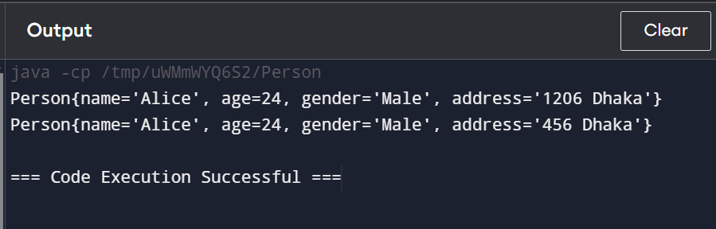

Lab Report Analysis:
• Encapsulation: The private instance variables of the Person class ensure that the data is kept inside and protected from external access.
The Getter and Setter methods provide controlled access to the class's data, ensuring its accuracy and allowing for any necessary edits or checks before making any changes.
• Flexibility: Using the Person class as a template, several person objects with different values for their attributes may be produced.

Conclusion:
The Person class effectively manages and encapsulates Person information. By using getter and setter methods, we have provided restricted access and the flexibility to check or update data as needed. There are several methods to expand upon this class in applications that use person data.
References and related material

Lab problem 2
INtroduction Our objective is to write a Java Person class that contains all of a person's personal data. They include their name, residence, age, and gender in this information. For each property, we will offer getter and setter methods to guarantee data encapsulation and integrity.

.

Lab Report: 1. Create a new Java class and assign a name to each class member.
2. Establish private variables for instances: Make name, age, gender, and address private variables. The pertinent personal information will be stored in these variables.
3. Apply getters and setters methods: Make these hidden variables available to the public and able to be changed.
o Getter methods: These methods return the value of the related private variable. For example, the getName() function returns the person's name.
o Setter methods: These allow you to change the value of the private variable. For example, the setName(String name) function sets the person's name.
Code:
public class Employee {
private String name;
private int id;
private double salary;
private String designation;

public Employee() {
}

public Employee(String name, int id, double salary, String designation) {
this.name = name;
this.id = id;
this.salary = salary;
this.designation = designation;
}

public String getName() {
return name;
}
public void setName(String name) {
this.name = name;
}

public int getId() {
return id;
}
public void setId(int id) {
this.id = id;
}
public double getSalary() {
return salary;
}

public void setSalary(double salary) {
this.salary = salary;
}
public String getDesignation() {
return designation;
}

public void setDesignation(String designation) {
this.designation = designation;
}

public String toString() {
return "Employee{" +
"name='" + name + '\'' +
", id=" + id +
", salary=" + salary +
", designation='" + designation + '\'' +
'}';
}
}
Part 2
public class Main {
public static void main(String[] args) {
Employee emp = new Employee("John Doe", 123, 50000.00, "Developer");

System.out.println(emp);

emp.setName("Jane Smith");
emp.setSalary(55000.00);
emp.setDesignation("Senior Developer");

System.out.println("Updated Employee: " + emp);
}
}
Analysis of the Lab Report:
• Encapsulation: The private instance variables of the Person class ensure that the data is kept inside and protected from external access.
The Getter and Setter methods provide controlled access to the class's data, ensuring its accuracy and allowing for any necessary edits or checks before making any changes.
• Flexibility: Using the Person class as a template, several person objects with different values for their attributes may be produced.

Conclusion:
In summary, the human class effectively manages and encapsulates human information. By using getter and setter methods, we have provided restricted access and the flexibility to check or update data as needed. There are several methods to expand upon this class in applications that use person data.

